CUSTOMER CHURN ANALYTICS
An Interactive Power BI Dashboard Project
Full Project Report

Prepared by
Bhati Devamjitsinh K
bhatidevamjit1776@gmail.com

Table of Contents

Abstract
This report presents the development of an interactive Customer Churn Analytics Dashboard built using Microsoft Power BI. The dashboard analyzes customer behavior, churn trends, revenue at risk, and high-risk customers through Power Query, DAX, and interactive visualizations. It brings together the full project lifecycle, from requirement analysis and data preparation through dashboard design, testing, validation, and the business insights the project delivered.

Introduction
Business Intelligence transforms raw data into actionable insights that support faster, more confident decision-making. This project applies that principle to telecom customer churn, using Power BI to convert a raw customer dataset into a dashboard that highlights where and why customers are leaving.

Objectives
- Analyze customer churn patterns across the telecom customer base.
- Identify high-risk customers who are most likely to churn.
- Monitor key performance indicators (KPIs) related to retention and revenue.
- Support data-driven business decisions with an interactive, self-service dashboard.

Scope
The project scope covers the design and delivery of an interactive dashboard featuring KPI cards, slicers, charts, a decomposition tree, and dedicated risk analysis views, enabling stakeholders to explore churn drivers at multiple levels of detail.

Dataset
The analysis is based on the Telco Customer Churn dataset, comprising 7,032 customer records across 21 attributes, including demographic details, account information, service subscriptions, billing data, and churn status.

Data Collection
The source CSV file was imported into Power BI and validated to confirm completeness and consistency before any transformation work began.

Data Cleaning
Data cleaning was performed in Power Query, where data types were checked and corrected, blank values were identified and handled, duplicate records were removed, and the necessary transformations were applied to prepare the dataset for modeling.

Data Modeling
The project uses a single-table data model, with all analytical logic implemented through DAX measures, keeping the model simple, fast, and easy to maintain.

Dashboard Features
- Executive KPI cards summarizing overall churn performance.
- Contract Analysis, breaking down churn by contract type.
- Internet Service and Payment Method analysis.
- Churn Distribution visuals across key customer segments.
- Top 10 High-Risk Customers view for targeted retention action.
- Root Cause Analysis via an interactive decomposition tree.
- Tenure Trend and Monthly Charges Trend visuals.
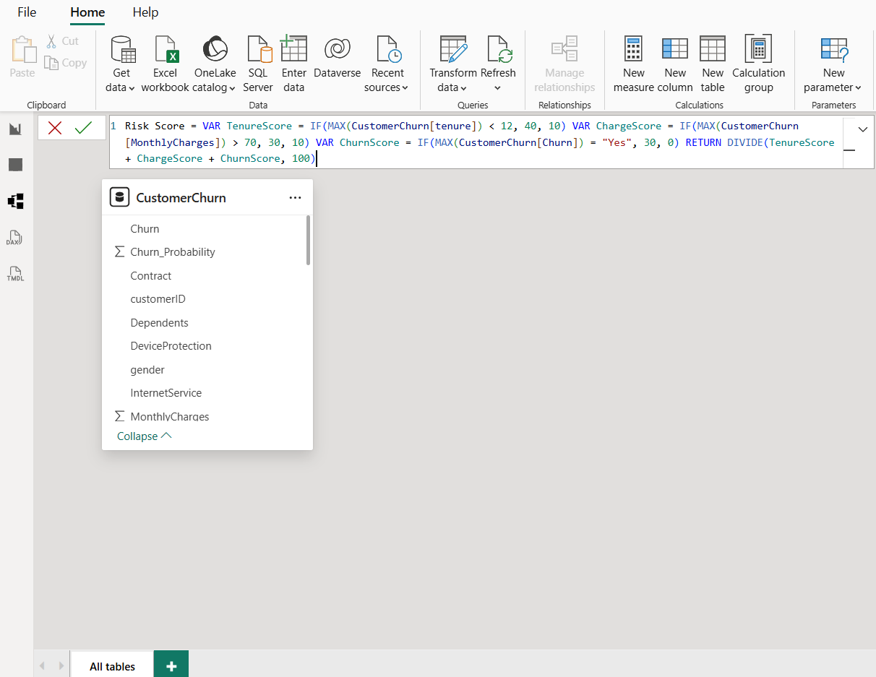
Figure 1: Customer Churn Analytics Dashboard overview.
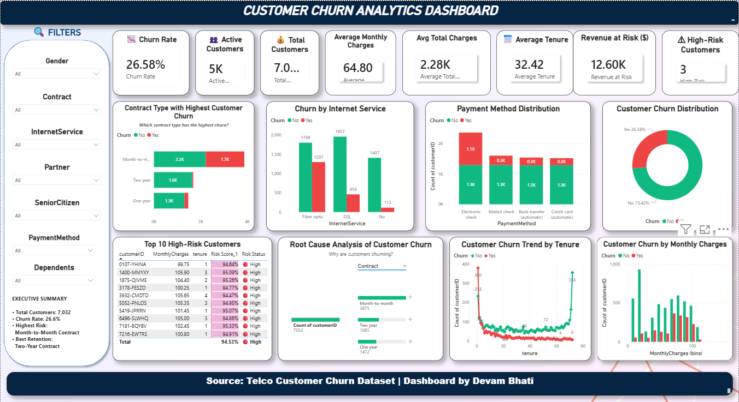
Figure 2: Sample DAX measures used in the data model.

Business Insights
- Month-to-month customers churn at a significantly higher rate than customers on longer contracts.
- Customers using Fiber Optic internet service show a higher churn rate.
- Customers who pay via Electronic Check exhibit higher churn compared to other payment methods.
- Customers in the early stages of their tenure are at the greatest risk of churning.

Recommendations
- Strengthen retention programs targeted at month-to-month customers.
- Incentivize migration to longer-term contracts.
- Enhance support quality for Fiber Optic customers.
- Automate ongoing churn monitoring so at-risk customers are flagged early.

Summary of Part I
Taken together, the dashboard built in this phase of the project provides actionable insights for customer retention and demonstrates the practical application of Business Intelligence skills across the full analytics workflow, from raw data to decision-ready visuals.

Chapter 19 – System Requirements
Delivering the dashboard required a defined set of hardware, software, and technology components.
- Hardware: a standard workstation with sufficient RAM for Power BI Desktop processing.
- Software: Microsoft Power BI Desktop, Microsoft Excel.
- Core technologies: Power Query for transformation and DAX for calculation logic.

Chapter 20 – Project Development Life Cycle
The project followed a structured development life cycle, moving through requirement analysis, data collection, data cleaning, data modeling, DAX development, dashboard design, testing, and finally publishing.

Chapter 21 – Dashboard Implementation
Implementation focused on translating the data model into a usable interface, combining executive KPIs, analytical charts, a decomposition tree, and interactive slicers within a coherent dashboard architecture.

Chapter 22 – Visualization Explanation
Each visual on the dashboard was designed to answer a specific business question.
- KPI cards: high-level summary of churn and customer volume.
- Contract analysis: churn behavior by contract type.
- Internet service analysis: churn by service type.
- Payment methods: churn by billing method.
- Tenure trends and monthly charges: how churn risk shifts over the customer lifecycle.
- Top 10 high-risk customers: a prioritized action list.
- Decomposition tree: root-cause drill-down across multiple dimensions.

Chapter 23 – Dashboard Testing
Testing covered functional checks, DAX measure validation, filter and cross-filtering behavior, and performance testing, confirming the dashboard responded correctly and efficiently under normal use.

Chapter 24 – Dashboard Validation
Validation confirmed the accuracy of KPIs, underlying dataset, calculations, and the correctness of dashboard interactions, ensuring the numbers shown could be trusted by business users.

Chapter 25 – Business Case Study
A telecom churn scenario was used to frame the project: the dashboard solution addressed the need to identify at-risk customers early, and the resulting business benefit was a clearer, faster path to targeted retention action.

Chapter 26 – SWOT Analysis
- Strengths: interactive visuals, clear KPIs, actionable segmentation.
- Weaknesses: single-table model limits some advanced scenario modeling.
- Opportunities: extend to predictive churn scoring and automated alerts.
- Threats: data quality or reporting cadence gaps could reduce dashboard reliability.

Chapter 27 – Challenges Faced
- Developing accurate and performant DAX measures.
- Designing a dashboard layout that stayed clear despite many metrics.
- Implementing a reliable customer risk score.
- Selecting the right visualization type for each business question.

Chapter 28 – Project Timeline
The project was implemented on a week-wise schedule, progressing from requirement analysis and data preparation in the early weeks through modeling, dashboard build, and final testing in later weeks.

Chapter 29 – Skills Gained
- Technical: Power Query, DAX, Power BI dashboard design.
- Analytical: churn analysis, root-cause investigation, KPI definition.
- Professional: structuring and communicating a complete BI project end-to-end.

Chapter 30 – Viva Questions
This chapter compiles common viva questions and answers relating to Power BI concepts and this project specifically, covering topics such as data modeling choices, DAX logic, and dashboard design decisions.

Chapter 31 – Interview Questions
This chapter compiles technical, business, and HR-style interview questions based on the dashboard, intended to help prepare for discussing the project in a professional interview setting.

Chapter 32 – Final Conclusion
Overall, the project demonstrates how a well-structured Power BI dashboard can turn raw telecom customer data into clear, decision-ready insight. Beyond the deliverable itself, it reinforced practical skills in data preparation, modeling, and visualization, and points toward future scope such as predictive churn scoring and automated retention alerts.

Final References
- Microsoft Learn – Power BI Documentation
- Microsoft Learn – DAX Documentation
- Kaggle – Telco Customer Churn Dataset
- Han, Kamber & Pei – Data Mining
- Stephen Few – Information Dashboard Design
- Kimball & Ross – The Data Warehouse Toolkit

